**AFJ Tracking App**

* **Firebase Database Setup**

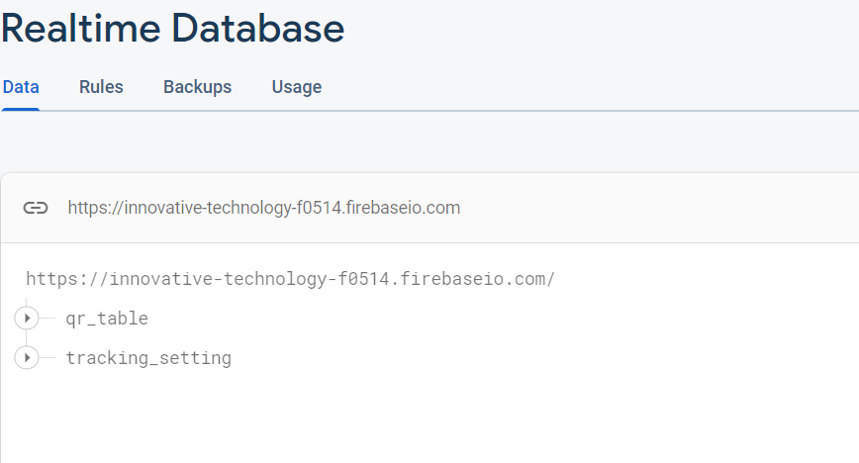

Create two Table of below name which are also define in Contants.kt file.

**qr_table** is used for validation of QR result which will update the status value and expire time from backend api using employee Scan vehicle tab.

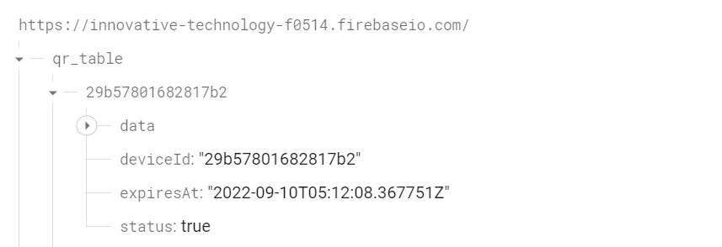

**Tracking_setting** this is used to enable the tracking enabled and disabled of every vechicle under the primary Key of device ID which check the status of tracking.

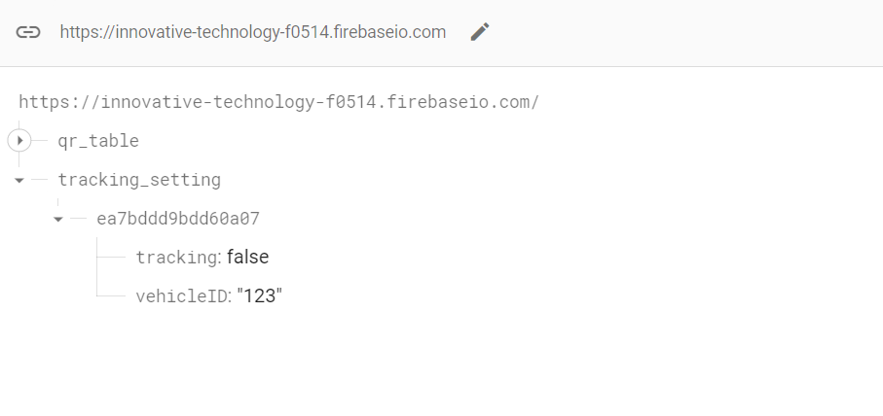

* **Firebase Remote Config Setup**

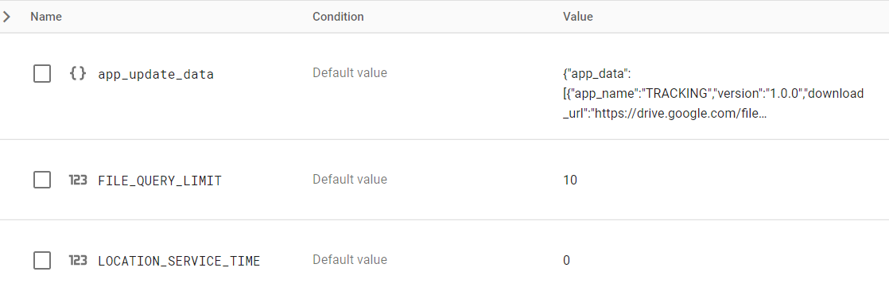

**app_update_data:** this is JSON type variable which is used for updating of apps according to there current running version every new link will be auto download if the version is different than the current running app version current.

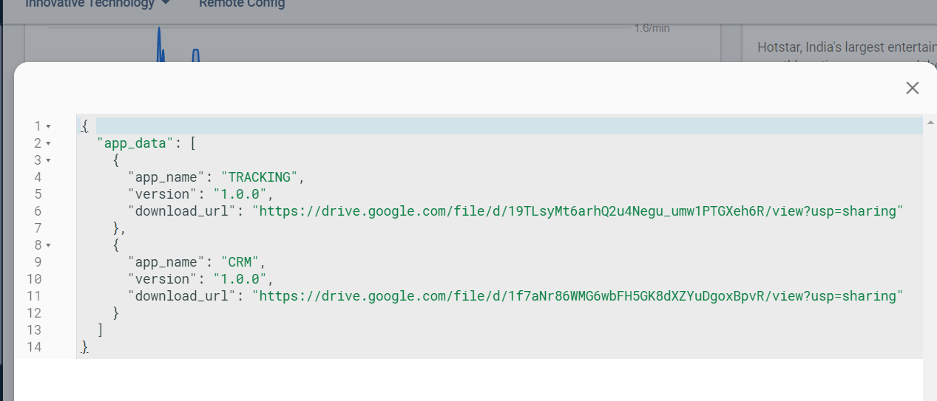

**File_query_limit:** this is an integer type variable which is used for the limit the row of offline database access value which is used to trigger the POST API of tracking application when device is connected to internet.

**Location_service_time:** this is an integer type variable used for interval of sending location data to server by default it is 0 because we are using 1 sec delay.